Q1. To study and implement java servlet to receive data from servlet request header and print the received data over web browser.

1. Create the Dynamic Project: click on File Menu -> New -> Dynamic Web Project and write project name and click next and select Generate web.xml deployment descriptor.

Ex: first

1. Create a servlet : For creating a servlet right click on src in your project -> New-> Servlet and write your servlet name. Ex. Hello -> uncheck all the checkboxes except do Get() -> next -> Finish.
2. Add servlet-api.jar file: For adding jar file right click on your project -> Build Path -> Configure Build Path-> Click Add External JARs button -> select servlet-api.jar from Tomcat Server lib folder.

**ReceiveData.html:**

<!DOCTYPE html>

<html>

<head>

<meta charset="ISO-8859-1">

<title>Demo 2</titl e>

</head>

<body>

<form action="servlet/Hello">

Name:<input type="text" name="user"/>

<input type="submit" value="go"/>

</form>

</body>

</html>

**Web.xml:**

<?xml version=*"1.0"* encoding=*"UTF-8"*?>

<web-app xmlns:xsi=*"http://www.w3.org/2001/XMLSchema-instance"* xmlns=*"http://xmlns.jcp.org/xml/ns/javaee"* xsi:schemaLocation=*"http://xmlns.jcp.org/xml/ns/javaee http://xmlns.jcp.org/xml/ns/javaee/web-app_4_0.xsd"* id=*"WebApp_ID"* version=*"4.0"*>

<display-name>DemoServlet2</display-name>

<welcome-file-list>

<welcome-file>ReceiveData.html</welcome-file>

<welcome-file>index.html</welcome-file>

<welcome-file>index.jsp</welcome-file>

<welcome-file>index.htm</welcome-file>

<welcome-file>default.html</welcome-file>

<welcome-file>default.jsp</welcome-file>

<welcome-file>default.htm</welcome-file>

</welcome-file-list>

<servlet>

<servlet-name>Hello</servlet-name>

<servlet-class>Hello</servlet-class>

</servlet>

<servlet-mapping>

<servlet-name>Hello</servlet-name>

<url-pattern>/servlet/Hello</url-pattern>

</servlet-mapping>

</web-app>

**Hello.java:**

import java.io.IOException;

import java.io.PrintWriter;

import javax.servlet.ServletException;

import javax.servlet.http.HttpServlet;

import javax.servlet.http.HttpServletRequest;

import javax.servlet.http.HttpServletResponse;

public class Hello extends HttpServlet {

public void doGet(HttpServletRequest request, HttpServletResponse response)

throws ServletException, IOException {

response.setContentType("text/html");

PrintWriter out = response.getWriter();

String name=request.getParameter("user");

out.print("Hello "+name);

out.close();

}

}

Output:

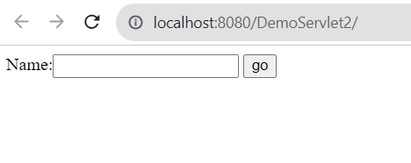

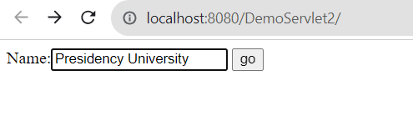

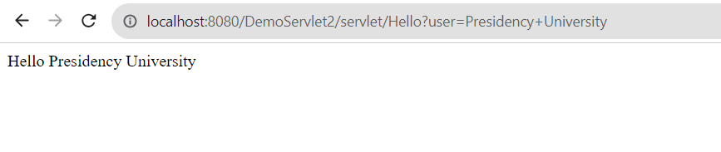

Q2. To study and implement java server page to print factorial value of an integer number, while the input is taken from an HTML form.

1. Create the Dynamic Project: click on File Menu -> New -> Dynamic Web Project and write project name and click next and select Generate web.xml deployment descriptor.

Ex: first

1. Create a servlet : For creating a servlet right click on src in your project -> New-> Servlet and write your servlet name. Ex. Fact -> uncheck all the checkboxes except doGet() -> next -> Finish.
2. Add servlet-api.jar file: For adding jar file right click on your project -> Build Path -> Configure Build Path-> Click Add External JARs button -> select servlet-api.jar from Tomcat Server lib folder.

**Factorial.html:**

<!DOCTYPE html>

<html>

<head>

<meta charset="ISO-8859-1">

<title>Demo 3-Factorial Computation</title>

</head>

<body>

<form action="servlet/fact">

Enter n value:<input type="text" name="user"/>

<input type="submit" value="go"/>

</form>

</body>

</html>

**Web.xml:**

<?xml version=*"1.0"* encoding=*"UTF-8"*?>

<web-app xmlns:xsi=*"http://www.w3.org/2001/XMLSchema-instance"* xmlns=*"http://xmlns.jcp.org/xml/ns/javaee"* xsi:schemaLocation=*"http://xmlns.jcp.org/xml/ns/javaee http://xmlns.jcp.org/xml/ns/javaee/web-app_4_0.xsd"* id=*"WebApp_ID"* version=*"4.0"*>

<display-name>DemoServlet3</display-name>

<welcome-file-list>

<welcome-file>Factorial.html</welcome-file>

<welcome-file>index.html</welcome-file>

<welcome-file>index.jsp</welcome-file>

<welcome-file>index.htm</welcome-file>

<welcome-file>default.html</welcome-file>

<welcome-file>default.jsp</welcome-file>

<welcome-file>default.htm</welcome-file>

</welcome-file-list>

<servlet>

<servlet-name>Factorial</servlet-name>

<servlet-class>Fact</servlet-class>

</servlet>

<servlet-mapping>

<servlet-name>Factorial</servlet-name>

<url-pattern>/servlet/fact</url-pattern>

</servlet-mapping>

</web-app>

**fact.java**

import java.io.IOException;

import java.io.PrintWriter;

import javax.servlet.ServletException;

import javax.servlet.http.HttpServlet;

import javax.servlet.http.HttpServletRequest;

import javax.servlet.http.HttpServletResponse;

public class Fact extends HttpServlet {

public void doGet(HttpServletRequest request, HttpServletResponse response)

throws ServletException, IOException {

response.setContentType("text/html");

PrintWriter out = response.getWriter();

int n=Integer.parseInt(request.getParameter("user"));

long f=1;

for(int i=1;i<=n;i++)

f=f*i;

out.print("Factorial of "+n+"is "+f);

out.close();

}}

**OUTPUT:**

